Project Proposal

CM2020 – Agile Software Projects Coursework 1

Date of Submission: 12 July 2021

|  |  |  |
| --- | --- | --- |
| **Created By:** | **Student Number** | **Student Email** |
| WENG ZHU EN NATHANAEL | 200261126 | zenweng001@mymail.sim.edu.sg |
| POOJA SURESH | 200261115 | suresh008@mymail.sim.edu.sg |
| LIM XUAN TING, JACE | 200629393 | xtjlim001@mymail.sim.edu.sg |
| FOO JO MUN | 200629430 | jmfoo003@mymail.sim.edu.sg |
| LIM WEE KIAT | 200629197 | wklim012@mymail.sim.edu.sg |

**Table of Contents**

**Aims and Objectives** **4**

Goals 4

Objectives 5

Project Scope 6

Challenges 6

**Planning and Requirements Gathering** **8**

Methods of gathering requirements 8

Results from the survey 9

Requirements for the app 21

Initial Workflow 21

Table which highlights the contribution of each team member 22

Graph between Task vs Duration taken to complete the task 23

Features of the app to be developed 24

Funnel based approach 24

Iterative Model 25

Agile Model 25

Working Environment 25

Future Scope 26

**Formative Testing and Evaluation** **27**

Market Research 27

Learning from survey results 29

User Persona 29

User Testing 30

**Prototyping Techniques** **31**

Previous prototyping and design (previous project idea) 31

Current prototyping and design (Spaceus app) 33

Previous project idea leading to the final idea 42

Limitations 42

Elements/pages not designed yet 43

Design validation 43

**Evaluation Techniques** **44**

How are the critical success factors classified? 44

Use scenarios or "use cases" 45

How to select Critical success factors? 46

The most common reasons for project failure are 47

Ways to measure project success 47

Example of Critical Success Factors 48

**Appendices** **49**

Appendix 1 49

Appendix 2 50

Appendix 3 52

Appendix 4 53

Appendix 5 56

Appendix 6 57

**Individual Contributions** **58**

**References** **59**

# 

# Aims and Objectives

## **Goals**

Spaceus: Our goal is to create an application that will help people find good study spaces. We want to be able to identify places that provide the optimal environment for a person to focus on their objective at hand, be it studying or doing work in general. Our application strives to provide an easy and excellent user experience and to allow our users to experience the major difference between good and bad studying environments. We also aim to integrate social functions for example linking with other people who study the same or similar modules to study together and help each other progress.

1) Application: Spaceus

2) Study space locator with built-in social features

3) Simple user experience

4) Appropriate functions

5) Simple yet elegant design.

## **Objectives**

Primary objectives:

1) Planning

2) Research

3) Creating a survey

4) Compiling survey data

5) Designing

6) Prototyping

7) Testing

Secondary objectives:

1) Gathering additional survey data

2) Possibly finding new functions to add

3) Exploring the social function

4) Collaborating with owners of the study spaces

## **Project Scope**

Project description:

This application (Spaceus) will be used by students to improve their productivity during study sessions.

Project objective:

To create an application that helps students find good study spaces, share their favorite study spaces, and find people with the same or similar subjects/fields to study with.

Project timeline:

This project will start with research and gathering data, then proceed onto designing and prototyping. After we have come to a good consensus, we will begin the development of the application. After the development is finished, we will test it within our private circle before releasing it to be used by the public.

Deliverables:

The Spaceus application will feature functions like:

1) Users will be able to add locations to the database

2) Users can search for optimal study environments to their liking with a filter function

3) Real-time crowd checker

4) Linking up with people who are studying similar modules

5) Distance indicators

## **Challenges**

The challenges we might face while building this application will be towards the back end of the product. Unfortunately, none of us in this group are experienced in creating applications. Coding and the functions used will be a huge gap to cover when creating this application, with the number of functions we desire to have, a lot of research and studying will have to be done to complete this app.

1) Coding

The biggest challenge that will come from this project will be coding the application. We must create a database and then enable users to edit that database, however, we do not want to allow the users to have free reign over it as well. We also need to add the log-in, account, filter, etc. functions to the application. We believe that making these functions work will be a very big challenge. Our current goal is to develop this into an android app, however, none of us has any experience in this. We will be experimenting with many platforms to try to create this app, we started the initial prototyping off with Figma and will try integrating it into Android Studio to create the actual app. Kotlin is the recommended and official language for building Android applications but none of us have any experience in this language, so learning this new language will be a challenge. However, the languages that we do know (Java, C++) can also be used in Android App Development.

2) Gathering data

As for gathering data, we need to look for study spots in Singapore that we can add to our app as a base. We also must gather potential users’ data for example their preferred study spot, environment, etc. The challenge was creating a survey that could answer all these questions that we had in mind and then send them out to gather the data we required. Another challenge is to find out all the mainstream study spaces like gathering data for where all the Starbucks, Coffee Beans, etc. are and their opening hours, whether they have power plugs or not if they are air-conditioned, what the ambient noise is like, so on and so forth, building the initial database will be quite a big hassle.

3) Research

There are many things that will require some research. We found an app, Fern, that is similar to what we want to achieve that is based in Texas, it is a study spot locator application. We can learn from their application how to appeal to users and learn from their strengths or flaws. Another thing that we want to look at is Waze, where we can look into their user input system, for example, how Waze allows users to warn other users about hazards on the road, we want users of our application to be able to warn other users of potential changes in the study spaces like maybe air conditioning is faulty or power plug is broken.

4) Timing

Due to the current situation of the world, it may not be the best time to release a product that encourages people to leave the house. Although the current pandemic might render this application unusable, we believe that this will only be the case in the near future.

# Planning and Requirements Gathering

## **Methods of gathering requirements**

**Analyzing Existing Documents**: Fern is a study spot app locator based in Texas. SWOT analysis was performed on the fern app to gather resources related to the strengths and threats which can be implemented on the Spaceus app. Few other resources and applications such as Waze were referred to collect ideas and take inspiration for our application.

**Questionnaires/Surveys**: A survey was created to gather responses regarding a user’s preference of study places, their opinion about studying with strangers, and the time they were willing to travel to find study places. Varying answers helped us to analyze different opinions to design the application better.

The questions which were asked in the survey are mentioned below.

1) Where do you normally study?

2) What would you consider a conducive study environment?

3) What are some essential features a study space needs?

4) How far in terms of travel time via public transport would you travel for a conducive study location? (e.g Less than 20 minutes of travel, more, etc.)

5) How often do you experience a situation where you are planning to study at a certain place but could not find a seat?

6) What affects your productivity when studying?

7) What can be done to improve the productivity of your study sessions?

8) When do you feel most productive?

9) Would you be open to studying with strangers?

10) Would studying the same topic with strangers improve your productivity and why? Please elaborate.

11) What time do you prefer to study?

12) How much time in a week do you spend studying outside home?

## **Results from the survey**

Questions 1 to 4 deal with the study environment the respondents would prefer and to know how far each user will be to travel since some users don’t mind traveling long distances. Here is what we gathered :

1) When asked about the places users commonly preferred to study

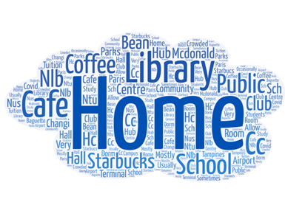

More than 3/4th of the respondents answered they would prefer to study at home followed by library and café having equal votes.

2) When asked about the characteristics of what a user considers a conducive environment

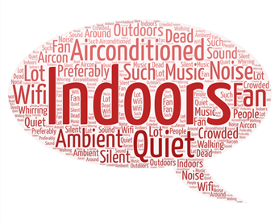

This question was drafted to know what factors can affect one’s productivity sessions to improve features in the app to possibly have filters such as noise levels and wifi availability to cater to user’s needs. The majority of the participants preferred to have study spaces that are indoors, air-conditioned, with Wi-Fi availability and ambient and quiet settings.

3) When asked about what are some essential features a study space needs?

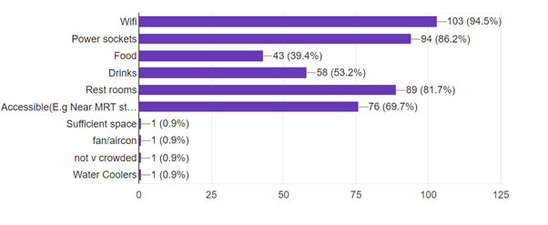

The majority of the survey respondents chose Wi-Fi followed by power sockets and restrooms. This was to figure out what were considered to be important factors for determining a study space.

4) When asked about how far survey respondents were willing to travel

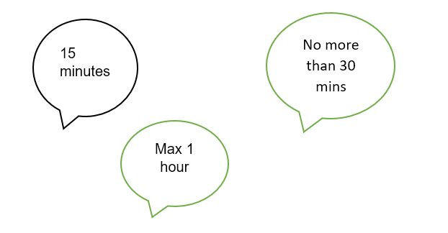

The majority of the respondents were willing to travel anywhere between 15 to 30 mins and a few also mentioned they can travel up to 1 hr to find a study location. This question helped us to analyze the importance of finding good study environments around the user's current location.

5) When asked about how often the participants of the survey were unable to find seats due to crowd levels

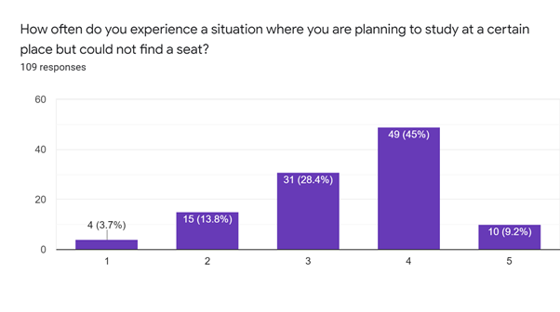

The majority of the participants selected 4 from a range of 1 to 5 given “1“ refers to not being able to find seats and “5” refers to being able to find seats. From the above question we were able to infer that the respondents were able to find seats only on some occasions.

Questions 6 to 10 dealt with productivity. The questions involved in asking users what factors affect one’s productivity and what can be done to have good study sessions

6) When asked about what affects user’s productivity while studying

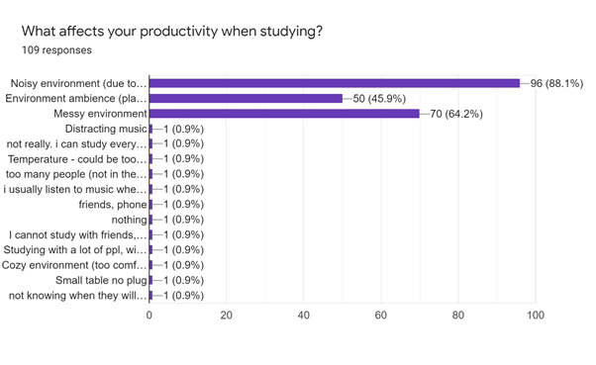

There were varying responses but noisy environment is in lead by 96 votes followed by messy environment and environment ambiance. This question helped us to analyze the user’s distractions which can help in designing the filters more effectively.

7) When asked about what improvements can be made to increase productivity

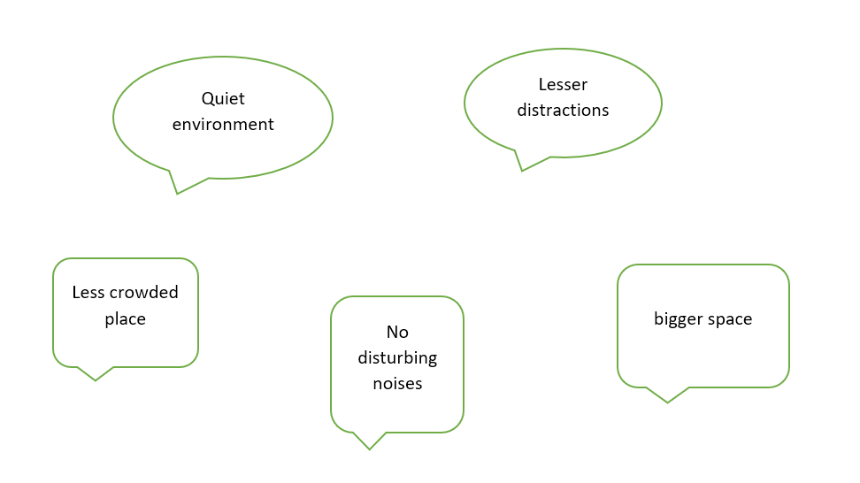

The speech bubble highlights the top five responses. The participants would prefer a quiet environment with fewer distractions. This gives us insight into what may be the distractions of the questionnaire respondents

8) When asked about whether users are most productive while studying with strangers or alone

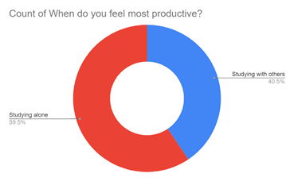

A huge amount of the respondents answered studying alone increases productivity rather than studying with others. This question allows us to decide regarding the features for the app

9) When asked whether those who responded to the survey would be open to studying with strangers

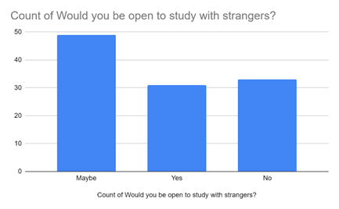

Those who submitted their responses to the survey responded with a “maybe” and almost equal levels of yes and no answers. One of the objectives of the app is to allow users the option to study with strangers, hence the question allowed us to have a rough idea about creating that type of feature.

10) When asked about whether they would be willing to study similar subjects with strangers

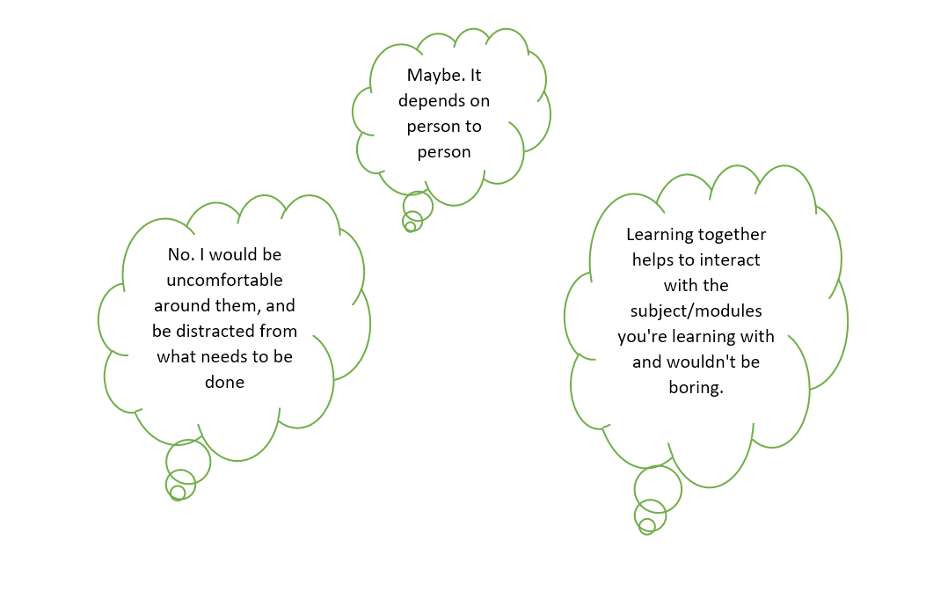

These are a few of the responses we received for the above question. The responses were mixed. The question was a follow-up question to the previous question. We wanted the users to elaborate on why they chose to answer a particular way to the previous question.

Questions 11 and 12 dealt with timings the users preferred to study and how many days they study per week.

11) When asked about the timings survey respondents preferred to study

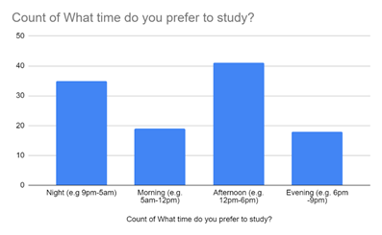

Those who responded to the survey responded that they prefer studying in the afternoon followed by night. This can also be helpful to provide study spaces for users to study anytime during the day.

12) When asked about how many days per week users preferred to study

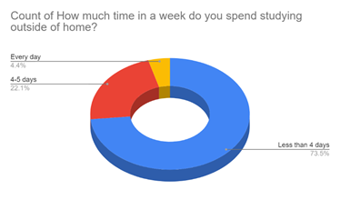

From the above chart, we were able to infer that users prefer to study less than four days and the number of users who study every day is significantly lesser. This can help us to analyze how many users may prefer using study spaces each week.

## **Requirements for the app**

1. Connectivity :

The user’s gadget will require a Wi-Fi module along with location services to connect to the internet at the spot we would like to go to, as well as to send and receive data from the database informing it of status changes and reservation confirmations if necessary. Bluetooth connections might also be required for those who might be driving and would prefer hearing directions

1. Size: The app is designed to be in gadgets that can be simple and convenient for users hence this software is designed to be used on android mobile phones
2. Ease of Use: This application must be useful for intended users. To achieve this. The application should have a simple design with a minimalistic interface along with easy navigation of the app.

## 

## **Initial Workflow**

Individually, team members were requested to propose their project ideas and do a SWOT analysis to make it easier to address all ideas as a group. The idea of creating an ebook reader website is chosen after reviewing all of the idea proposals since it allows the central idea to be developed in a variety of ways. After that, the use of templates from websites like WIX is explored. Following that, each team member decided to come up with research questions that could arise during the development of the ebook reader.

Each of us submitted a prototype design, from which one was selected. We also chose to create task flows for the E-Book Reader website's login and administrative pages. We decided to change concepts because the idea did not align with the vision we were attempting to achieve since the E-book Reader was better suited to be a website rather an app, Thus we brainstormed new ideas and came up with a new project topic, "Spaceus - Study Spot Locator," and started discussing the app's features and a new prototype. To acquire a better knowledge of the app's functionalities, we also decided to send out surveys to our target demographic.

Appendix 1 contains a diagram of our workflow.

## **Table which highlights the contribution of each team member**

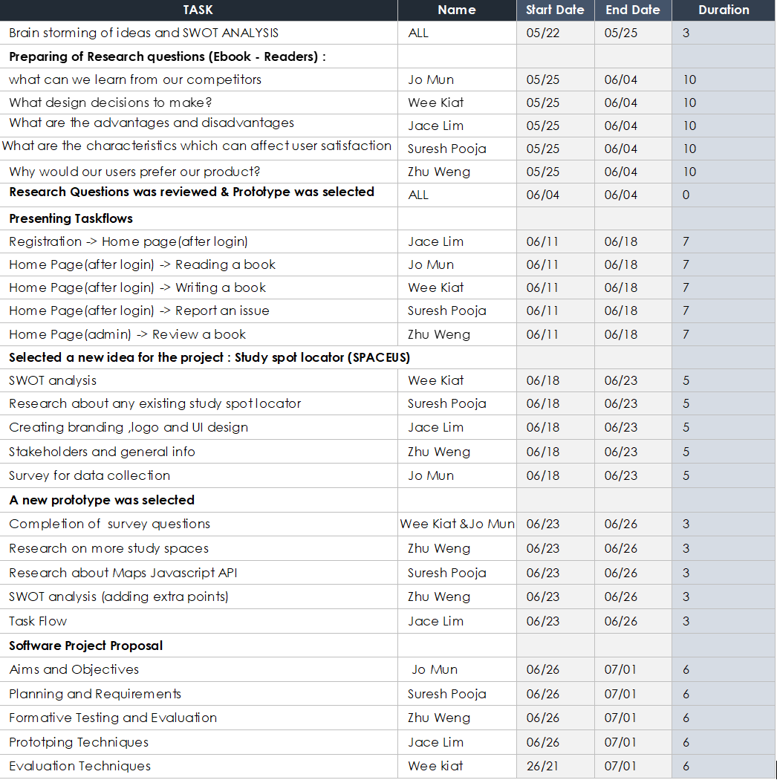

The tasks completed by each team member throughout the design phase of the project are listed in the table above. Each assignment was meant to be finished before the following meeting. This table is a more detailed version of the original workflow diagram. The division of each activity into subtasks allowed us to concentrate on one task at a time, resulting in a more productive process.

## **Graph between Task vs Duration taken to complete the task**

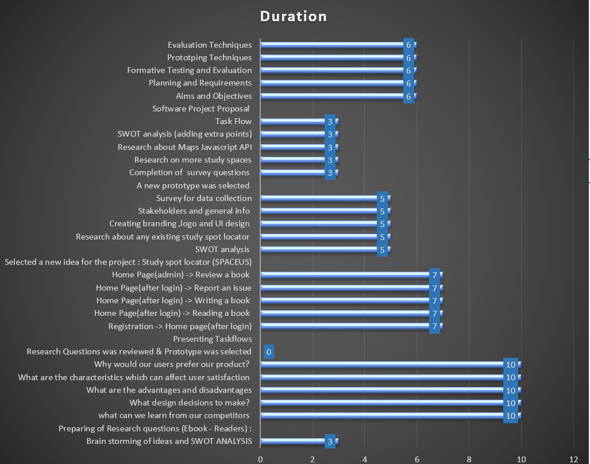

The graph above shows the duration taken to complete a set of goals. The "duration" on the graph refers to the days between one meeting to another meeting. Having a deadline to complete each set of tasks kept us on pace, and the weekly group sessions helped us examine our shortcomings while also motivating us to track our progress. We were able to focus on one piece of work at a time by breaking down a single task into many sub-tasks. Finding each team member's strengths and weaknesses during the ice breaker activity was beneficial since they were assigned work based on their strengths, allowing them to complete the tasks more quickly and effectively before the deadline.

## **Features of the app to be developed**

1) Login/Sign up page

2) Forgot password

3) Add place: allows users to add location along with relevant information about the place

4) Filters: Crowd size, Wifi availability, noise levels, Plug Points, and distance taken to  
 travel.

5) Crowd check: Allows users to check estimated crowd size

6) Nearby places: Allows users to find nearby study places with respect to the location

## **Funnel based approach**

Top of the funnel: When a user begins to explore a product, they may be unsure about their own needs with the product. They may also devote time to do product research. The user can look for apps on Google Play and then run a Google search based on what they find.

Middle of the funnel: Users may have come across other apps offered through adverts on social media or through search engine marketing.

Bottom of the funnel: Before purchasing an app, the user may have chosen an app, and based on the reviews and information

**Approaches:**

* Agile
* User-Centered Design

**Customer Focus:** All activities are focused on ensuring a useful, usable, and engaging product. The customer is not defined as the project stakeholders, but the end-users as well.

## **Iterative Model**

The iterative model does not prioritize gathering requirements; instead, it begins by creating and specifying a portion of the program, which can then be examined at a later stage to produce more needs. This is then repeated, resulting in new software versions.

## **Agile Model**

This approach allowed the team to have flexibility with the ideas:

* Manage change of ideas
* Focus on the highest priorities
* Helped to make better use of the resources
* Increased productivity due to combined efforts
* Allowed us to provide better output more quickly through short interactive meetings
* Enabled Time estimation i.e Time taken to complete certain tasks
* The development process involved a lot of interactions with the team.

## **Working Environment**

Kotlin is a computer language that can interoperate with Java . It can be used for a variety of purposes, including generating Android apps in this case. Android is a mobile operating system and open-source software platform based on Linux. It employs object-oriented programming which allows the reusability of code along with a simple syntax, which makes a language easy to read, write, and maintain

**Developmental Platform:**

Android Studio is a unified environment where we can build android applications for various devices. Structured code modules allow us to divide our project into units of functionality that we can independently build, test, and debug.

**Other technologies used**

Figma was used to design prototypes

Miro and Figma were used to create task flows

**Languages:**

* Kotlin

## **Future Scope**

For designing a working prototype of the app. We chose to work with Android studio. Android studio is a virtual environment that aids in the development of Android applications. Because our software includes a map, it can be particularly helpful for users to find their present position and also identify study locations in the surrounding area. The team has decided to study more about Kotlin, the programming language used by Android Studio. The android studio also contains other projects, one of which being Google Maps for Android, following which we would begin developing filters for the app and implementing other activities such as a login/signup page to create a viable application. We hope that by using this product, users will be able to spend less time looking for study spaces and more time to complete their tasks.

# 

# 

# Formative Testing and Evaluation

## **Market Research**

**Case study 1: Waze app**

Waze app is a mobile app, on both iOS and Android, that enables users to plan their travel routes and change them while on the way, according to real-time updates on traffic situations. It takes crowdsourced traffic information and helps users to adapt their travel route to other factors, like traffic, police cameras, or speed limits. Appendix 2 contains screenshots of the app.

Functions:

* Uses icons to flag things like police, traffic cameras
* Users able to save places under “Favorites”
* Trips can be scheduled under “Planned drives”
* Crowd sourced information on roads
* Real-time updates on the map
* Custom maps
* Also flags location of users
* Zoom feature
* Color coding for crowd level
* Collaborates with stakeholders to improve data

What can we learn to use in Spaceus?

* Use icons to flag things like F&B, toilets, vending machines
* Custom maps for study locations with live updates from community information
* Location flagging for users, study groups, can help to organize crowd
* Color code for crowd level

Disadvantages of the above:

* Overuse of icons can result in clutter.
* Custom maps are unreliable without up-to-date data due to recent changes.

(Tables shifted for the event, restricted seating due to covid, unorthodox furniture making it difficult to accurately “calculate” space.)

* Not all users are willing to share data like location or even study locations.
* Color code may not be as useful due to study areas being different from roads.

**Case study 2: Fern app**

Fern App is a web-based app that relies on crowdsourced information for study locations.

The app has a search bar to search for locations and a filter results button to filter for results based on user selection. The filters are based on 4 options: Wifi, Noise, Seating, and Power Outlets. There is also an option, Search by Map located near the filter results, that enables users to find a location on the map. Users can create a user profile and add a list of places in our profile for easier navigation. Appendix 3 contains a screenshot of the home page.

Functions:

* Search function with filters
* Able to search for nearby study locations around the user
* Add new locations for studying
* Users can create profiles so that their preferences and favorite locations are saved

Good points:

* Uses symbols to represent filters, which makes it intuitive to understand.
* A simple interface is easy to navigate
* Compact design maximizes the map view

Bad points:

* Not intuitive to use as not all functions are clear due to compact design
* Not capable of resizing itself to fit a wide range of screens
* Limited functionalities
* Does not load quickly

## 

## **Learning from survey results**

As earlier mentioned, we performed a survey to better understand the user requirements. We had a total of 111 respondents and from them, we received a mixed set of data. When we evaluate our prototype, we need to find out if our product is effective, efficient, and satisfies users. To better understand the criteria for usability, we have to understand what users need and want out of an app like this. Below are some diagrams based on the survey results, that have been processed from a mixture of quantitative and qualitative data, that will be relevant to setting standards for our prototype testing.

From the data in Appendix 4 Fig 1, we can see that a large majority of users study at home. When they study outside, the top three options are as follows: Cafe, Library, School. This suggests that across the target audience, they are likely to frequently said locations and identify them to be conducive for work.

Appendix 4 Fig 2 also tells us that users need a quiet, air-conditioned environment for them to be productive. This overlaps with the features of cafes, libraries, and schools, making these likely be the reasons why users study at these locations.

Appendix 4 Fig 3 shows what essential features users think a study location should have. Wifi, Power Sockets, and Restrooms are listed among the top three features. Users are likely to download our app in hopes of finding locations that match these criteria. Thus, we can conclude that if we include functions that are relevant to the app, it can make the app enjoyable to use.

## **User Persona**

Based on the survey data, we have generated a user persona. While our target audience is students, other potential users include work from home staff and people just looking for a quiet place to sit. Hence, we made a profile for our users, Cafe Cammy. Cafe Cammy likes to study alone at quiet locations that are air-conditioned, with Wifi and power sockets readily available. She dislikes noisy places with bad lighting that takes more than 30 minutes to get to. While Cafe Cammy stays at home to study most of the time, she occasionally studies at cafes and libraries, usually in the afternoon or nighttime. Cafe Cammy is a general image of what our users should be like. Appendix 5 contains a diagram summarising information on Cafe Cammy’s like factors they consider to be a conducive study environment and their habits.

## **User Testing**

Our current prototype is a Figma prototype with no actual code. The prototype merely switches between fixed images of what we envisioned the app to be like, with each button swapping between the relevant images. Since we have limited functionalities, we have not yet done any user testing.

Our group intends to ask users from different student groups to view the interface and try using the prototype. Success will be measured for each function in terms of effectiveness, efficiency, and user satisfaction. The evaluation criteria for effectiveness is whether or not the user can achieve an outcome. For efficiency, it is how quickly a user can achieve the outcome without extra steps. For user satisfaction, it is how pleasant the process of achieving the outcome is. An example of a table used for filling in testing data and an example set of questions has been included below.

Example Evaluation table:

|  |  |  |  |  |  |
| --- | --- | --- | --- | --- | --- |
| Function | Question | Effectiveness | Efficiency | Satisfaction | Comments |
| Sign up |  | Yes | No | Yes | Too tedious to sign up |
| Sign up |  |  |  |  |  |
| Login |  |  |  |  |  |
| Search |  |  |  |  |  |

Example questions:

1. Are you able to find the Search Function? Why? Yes/No, comments
2. Can you figure out how to use the Search function? Why? Yes/No, comments
3. Do the features included in the Search function help? Why? Yes/No, comments

Over the course of development, more testing will be needed. Users will know what they need and want. By continuously testing each version of the prototype, users will be able to point out flaws in the prototype. This is called iterative user testing, and this process helps us to build on the current prototype and improve its functionality over the software development life cycle. We need to be prepared to trial our prototype on a wide variety of users that match our user persona, with different conditions and scenarios, in order to thoroughly ready the application for usage in real-world conditions.

# Prototyping Techniques

Our project will focus on an Android mobile application. Some strengths of our project being an app would include:

1. Portability - users can easily ‘carry around’ our application without the need for a laptop.
2. Ease of access - clicking our app would be considerably faster as compared to clicking our/competitor’s website/web-based application. (A web app would require typing in a link into the search bar of a laptop or mobile device and would take a longer time to access as compared to simply clicking on our mobile app)

The weaknesses of our project being an app would include:

1. Having to download the app - users will be required to download the app to use our app. Some users might not like the idea of having to download the app as it takes up space.
2. Complicated - developing an app will be fairly complex for us as the group does not have any experience in creating/developing apps.

## **Previous prototyping and design (previous project idea)**

Prior to deciding on our idea for the mid-term, we were working on another idea for a web-based eBook maker. The online eBook maker aimed at providing writers a free platform to write their unique stories and convert them to eBooks.

Our target audience of writers included people who write as a hobby looking to create their eBooks, people who are experienced in writing to people who have no experience in writing but would like to create their ebooks.

The images attached below are the home and create pages of what the online eBook maker would have looked like. The design and prototype for this project idea were done using Figma. This was our first time using Figma and we had a little difficulty navigating the interface at first. Another prototyping platform that was considered was Invision but we found Figma easier to navigate around as compared to Invision.

The color scheme that was chosen for this 1st project idea was a neutral color palette, allowing the web application to look clean. As users for the online eBook maker would be spending a substantial amount of time on the platform typing their stories out, neutral colors like white, sand, and black were best suited as they would not cause problems like eye strain to the user as quickly as compared to bright and striking colors.

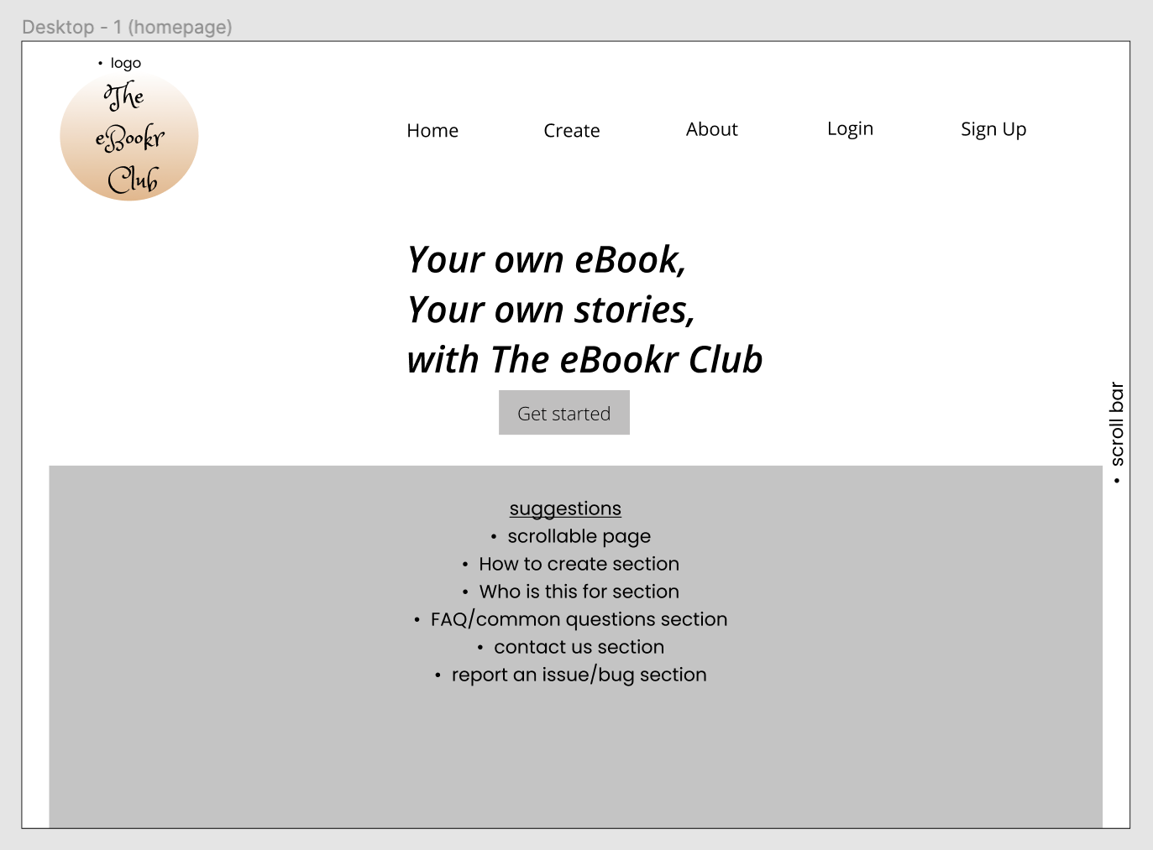

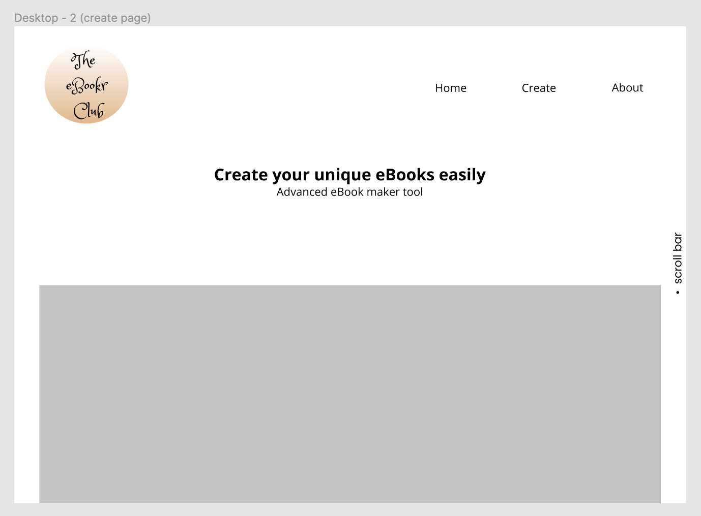

*Rough design of online eBook maker*

## **Current prototyping and design (Spaceus app)**

Spaceus (pronounced *spay-c-us*) is a study spot locator app based in Singapore, aiming to help local Singaporeans to find local places to study/work at.

When coming up with the brand name, we decided to go with a 1-word brand as it was more unique and eye-catching. As our project idea is on a study spot locator, we felt including words like ‘space’ and ‘spaces’ in our brand name would be appropriate. Spaceus was then thought out after a few days of brainstorming and writing out names and is a wordplay on the word ‘spaces’. The brand name also represents our group and project as a whole with ‘us’ included at the end.

***Blue version,***

Figma was also used for the designing and prototyping of our current and final project idea; Spaceus. We came up with color palettes first; there were 2. The first design we came up with was a muted blue palette.

As Spaceus is a study spot locator app that aims to provide users with peaceful and conducive environments to study/work at, blue was a good color scheme to start off with as it calls to mind feelings of calmness and serenity. Instead of a bright solid blue, different shades of muted blue were chosen as they would not appear too harsh to the users.

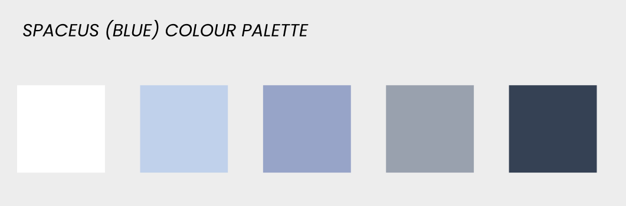

*Blue colour palette (1st design of Spaceus)*

**

*Logo for the blue version of Spaceus*

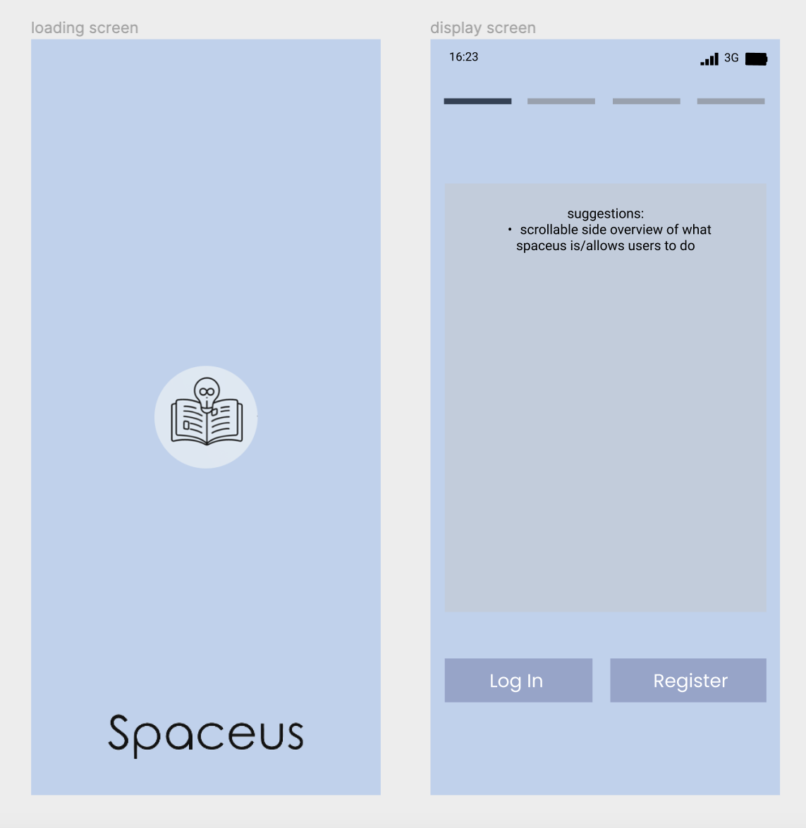

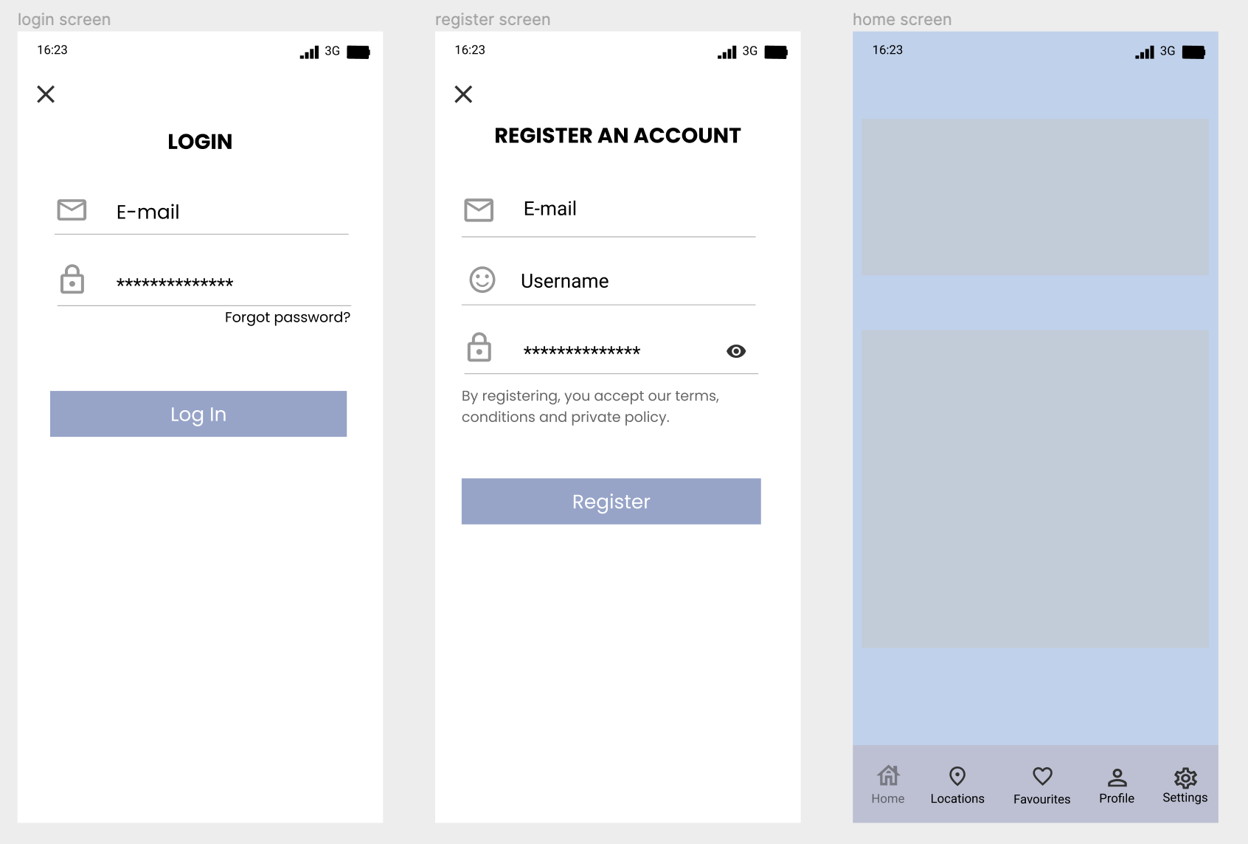

*Blue version of Spaceus app*

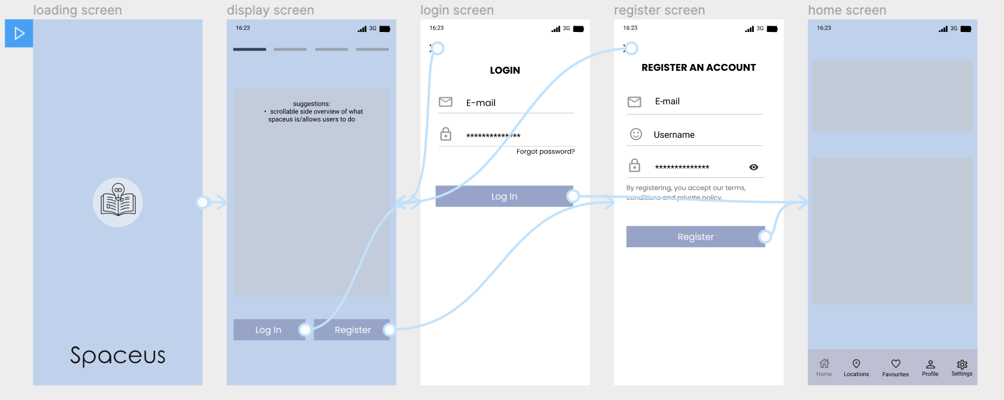

*Prototyping of blue version*

***Neutral version (the final version of Spaceus),***

Another color scheme that was created for Spaceus was a nude/neutral one. Neutral colors were chosen as they are practical and can provide a sense of warmth and solace; we want our users to feel a sense of comfort when using our app. Using gaudy colors would deter users from staying in our app or might deter them completely due to problems like eyestrain, headaches, and so on.

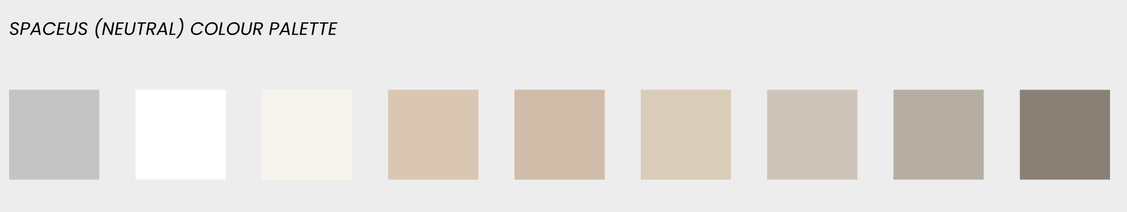

*Neutral colour palette (2nd design of Spaceus)*

Our logo consists of the brand name and a picture of a doorway; the doorway represents going out to discover what is outside. In our project’s context, it allows and encourages users to go out and explore/find new study spots in Singapore, with the help of our app.

Using our app, users would be able to find new study spots that they’ve never heard of/been to, promoting an enriching lifestyle. (Enriching lifestyle in this context refers to our users going out and discovering new places for study/doing work and in turn also discovering what places they may/may not like, and potentially meeting new people)

**

*Logo of Spaceus*

Figma was also used for designing and prototyping this version of Spaceus. Following the color palette, we then created the design from scratch.

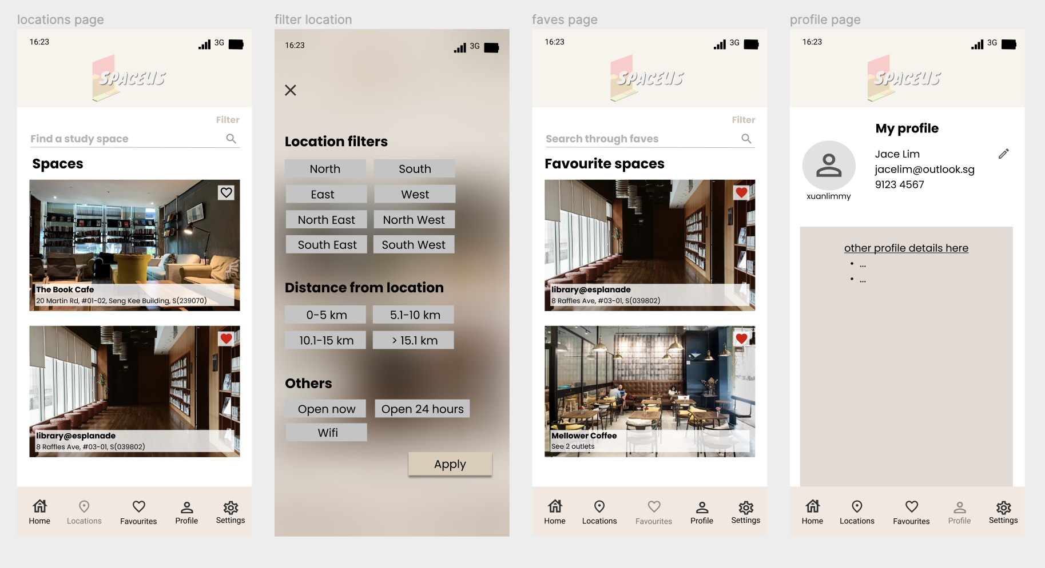

*The neutral version of Spaceus (final look of the color app)*

For prototyping, we used the prototype function in Figma to help us create and visualize the navigation and flow of the app. Miro was used to creating the task flow diagrams.

The app starts with the loading screen being displayed when the user clicks into the app. If the user does not have an account, they will have to register an account with us. Input validation will be done and if everything the user has inputted is valid, their account will be created and they will be logged in successfully into the home page.

If any fields are not valid, the user will be asked to fill up the registration form again. If the user were to have an existing account already, they would just have to enter their credentials; successful login would bring the user to the home page while an unsuccessful login attempt would require the user to re-enter their credentials again, this process repeats until the user logs in successfully.

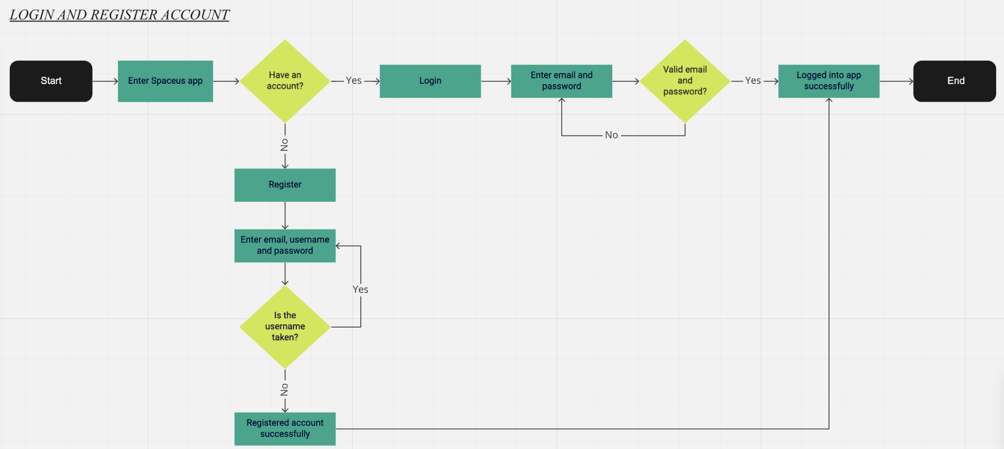

*Task flow diagram of login and register account process*

This task flow diagram (attached below), focuses on the process of the user forgetting their password. The process starts with the user entering the app and attempting to log in.

If the user forgets their password, they can request a password change and will receive an email with the link to change their password. They will then input their new password and validation will be done to ensure that the new password input meets the requirements. If the new password does not meet the requirements, it will get rejected and the user would have to choose/modify the new password. Upon successful change of the new password, the user will then be able to log in with their new password.

If the user does not forget their password, they will simply input their email and password. Correct login credentials will allow the user to be logged into the app successfully after validation check. Incorrect login credentials would lead to the user having to re-enter their credentials, this process repeats itself until the users’ credentials are correct. They will then be logged into the app and the home page will be displayed.

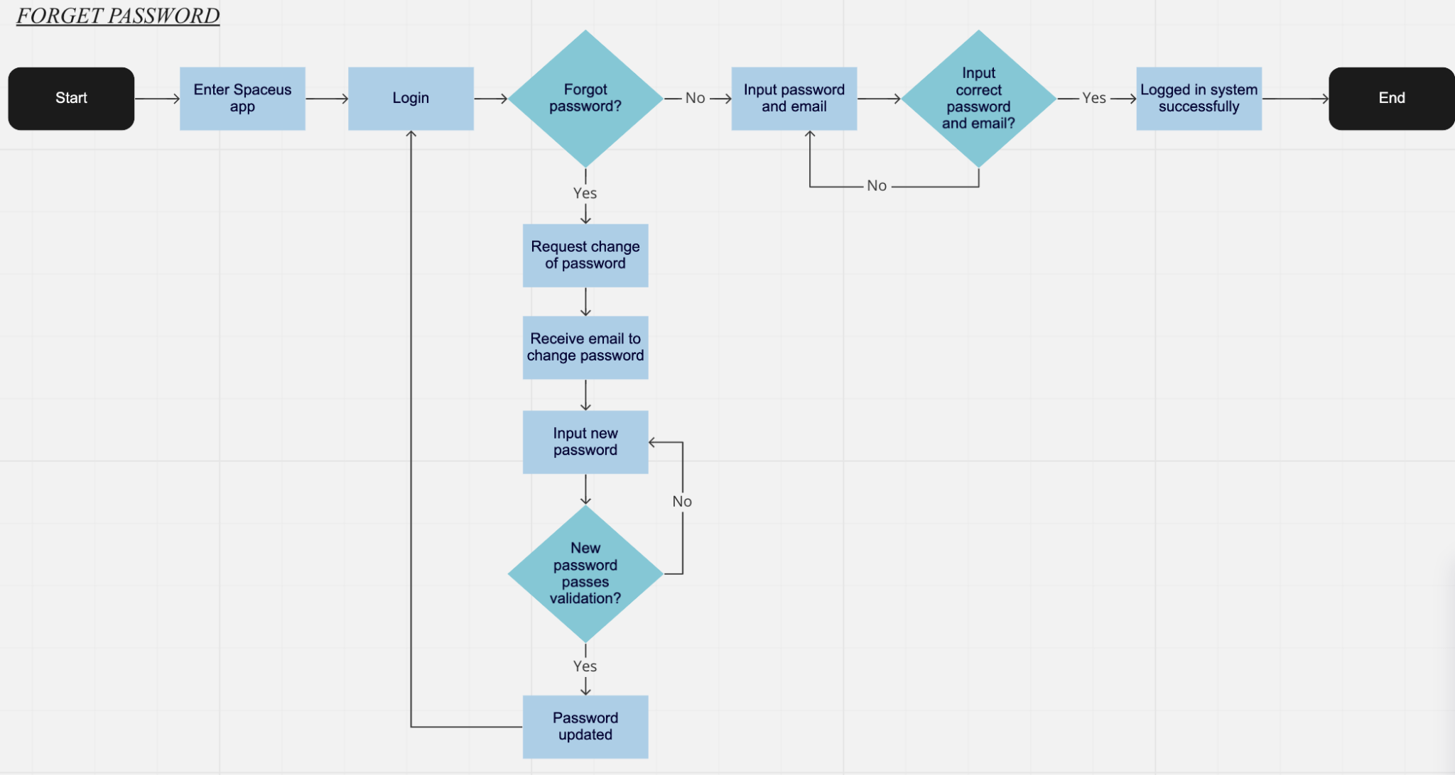

*Task flow diagram of forget password process*

This task flow (photo attached below) focuses on the add new location process. The process starts with the user entering the app and being on the locations tab.

The user then chooses to add a new location and they will enter the details required i.e location name, address, and so on. A validation check is then done to ensure that all required fields are filled properly and the address given is a valid non-residential address in Singapore. If either of these 2 requirements is not met, the new location form will not be sent for approval and the user would have to re-enter the location details again.

If the details entered are valid, the request to add a new location will be sent for approval. If the new location submitted is approved, the location and its details will be added into the database and it will be displayed on the app. If the new location is rejected, the user (should they wish to add a new location) would have to request another new location to be added. This process will repeat until the new location is approved and the location is added into the database.

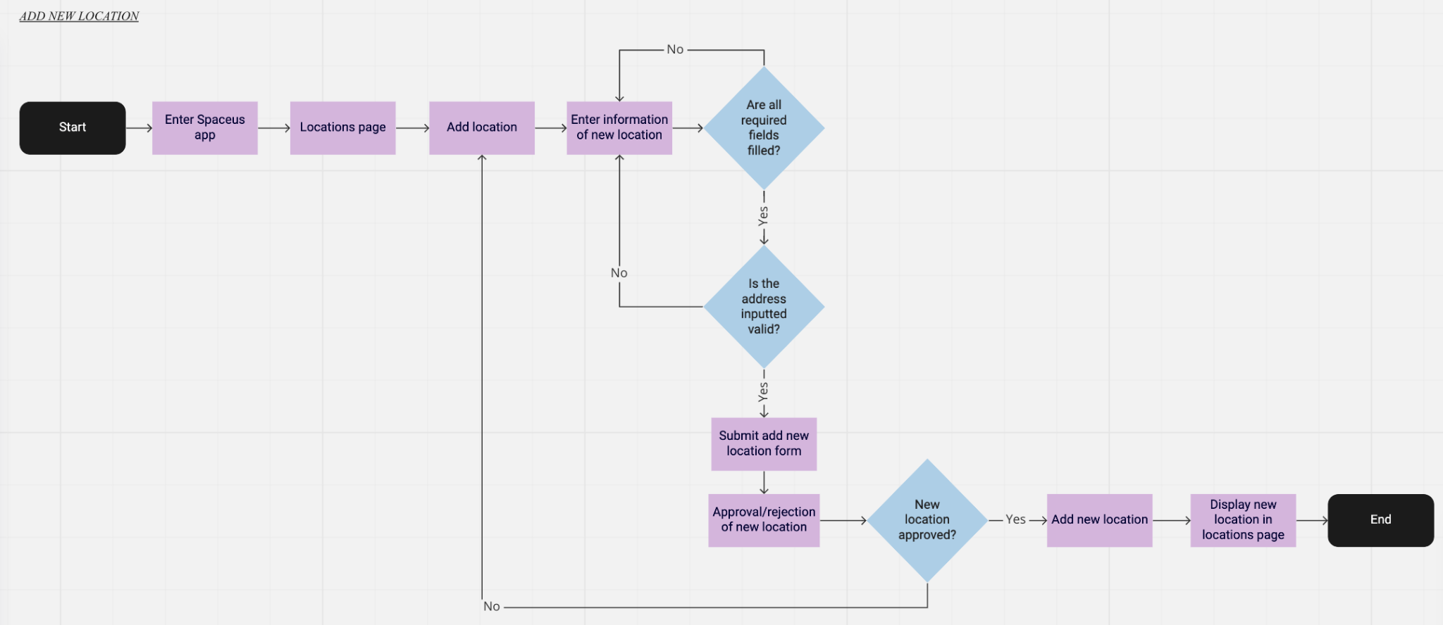

*Task flow diagram of add new location*

*For easier viewing of the task flow diagrams, the links to the task flow diagrams on Miro have been attached in Appendix 6.*

The 2 photos attached below are the screenshots of the prototyping done together with the design in Figma. The arrows show the navigation and flow from one component to another in the app whenever the user clicks on a certain component i.e if a user were to click the ‘create now’ button at the login page by accident, they would be able to click the back arrow button and they will be redirected back the login page instead.

The arrows in the 2nd photo mostly show the navigation for the tab bar at the bottom of every page, allowing the user to go to different sections of the app regardless of what section they are in i.e the user would be able to access the favorites page from the home page, locations page, profile page or settings page, same for any other section.  
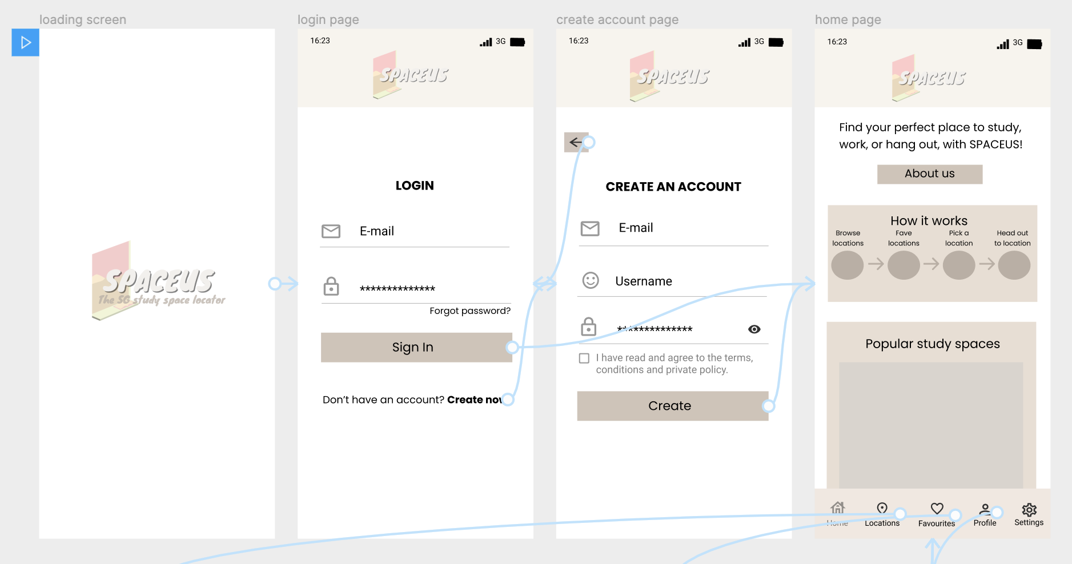

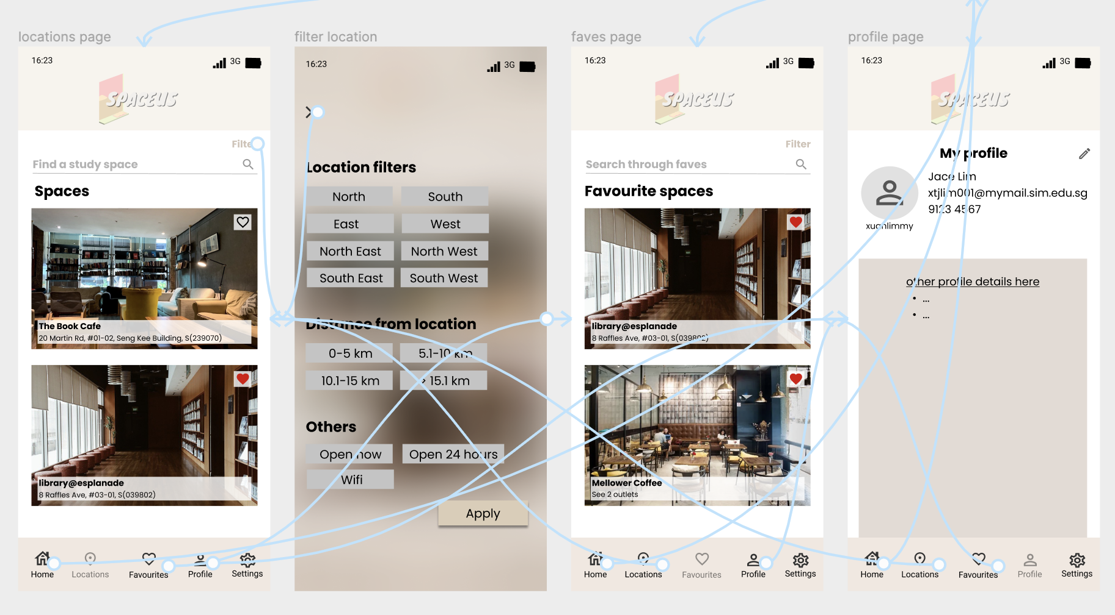

*Prototype of Spaceus*

## **Previous project idea leading to the final idea**

As mentioned above, our project group had the initial idea to create a web-based eBook online maker. However, we decided to change our project idea and focus as we found the eBook maker idea to be quite abundant and developed in the market; there are many other competitors in the market.

Besides the number of competitors there are, another concern we had was that it was difficult to differentiate ourselves from the existing eBook makers in the market. We did come up with the idea of focusing on writers writing their own unique stories into eBooks instead of turning existing books (by published authors etc) into eBooks (without permission/permit). This unique factor not only allowed us to differentiate ourselves from competitors, but it also addressed the copyright issue (turning copyrighted published books into eBooks without consent from publishers, etc) that we were concerned about.

Despite coming up with that unique factor, we felt that the online eBook maker idea had very limited potential and growth (due to the extremely saturated market). As such, we decided to change our focus to an idea that had potential and growth as well; leading us to come up with Spaceus.

## **Limitations**

Figma can be a good platform for designing and prototyping but there are still some limitations like not being able to make a scrollable prototype.

Prototypes done in Figma have to be done per frame/page (prototype attached in photos above) i.e. loading screen is a page, the home page is a page and so on, it does not allow prototypes to scroll i.e. being able to scroll the home page on the app, this is a disadvantage as pages of the app would have to be created and designed individually, taking up a lot of time and will require many frames. Some frames will be similar to others; one frame could show the original page and the next frame would show a slightly modified version of the same page.

Because of the lack of scrollable frames/pages, it makes it difficult to have a more accurate view and “feel” of how the end product would be like and how it will work because a real functioning app has scrollable pages that allow users to scroll the different pages/sections of the app. Viewing a prototype by each frame (instead of a scrollable page) makes it less realistic and the experience is not as great.

## 

## **Elements/pages not designed yet**

Despite having created a detailed design and prototype, there are still elements and pages of the app not designed and added into the navigation/flow of the app. Those pages not designed and prototyped yet are more detailed processes i.e. nearby me and recommended. The pages that have been designed and prototyped are basic pages/processes i.e. login page, the home page, locations page, and so on.

Moving forward, more pages and processes will be designed and prototyped to present what our app would look like and how it will function when used by users. Additional new design elements/components (if any) will also be added to our design and prototype as we go along. All in all, basic components, pages, and prototyping have been designed and created and will be our template for how our app will look like.

## **Design validation**

W3C validation was done on the final design (neutral color palette) and the result showed that there were no major errors.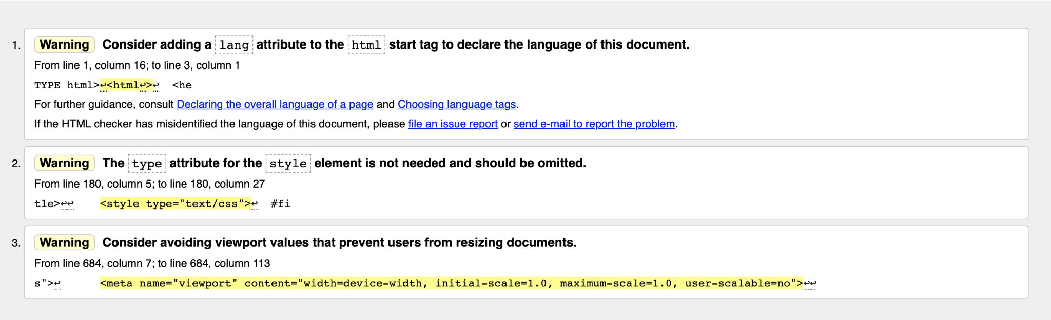

# Evaluation Techniques

Evaluation techniques are to examine the system's functionality and usefulness. The process of evaluation techniques is making a value assessment based on information from one or more sources. The goal for evaluation techniques is to evaluate the impact of the interface on users and identify specific issues. Depending on the data to be assessed, many different assessment types and methods can be used such as Formative evaluations, summative evaluations, process evaluations, outcome evaluations, etc. In this case, we use summative evaluations as our evaluation techniques in the Spaceus application. Summative evaluation occurs after a larger chunk of content, a module, or a program has been delivered. The evaluation discusses the program's overall efficacy and offers ideas for improvement. For example, we created a Google form for our users to conduct surveys to gather information. In this action, we can know whether our service can meet the needs of users.

Besides, critical success factors (CSF) are to help the team or organization decide what they should focus on and compare progress with established goals to achieve its goals so it can help to eliminate irrelevant performance indicators. The successful implementation of these success factors should produce positive results and create meaningful value for the company.

## **How are the critical success factors classified?**

The critical success factors can be divided into 4 categories which are environmental factors, industry factors, strategic factors, and temporal factors.

* **Environmental factors**

Environmental factors are events occurring outside of the corporation over which the company has no direct influence. For example, the economy, the competitors, business environment, new technologies, etc are the elements under this category. In this case, we need to keep track of the situation and maintain a leading position by identifying environmental factors that may affect its ability to complete tasks. For example, the study space is critical to the user's ability to learn effectively. It can be seen from the survey that more and more users prefer a quiet indoor environment.

* **Industry factors**

These are the things you must do to stay competitive in your industry. For example, an airline might focus on “on-time service”. In this case, our Spaceus will focus on providing a good learning environment so that more users can focus on learning. Users can use the Spaceus app to share some favorite learning spaces and let more users know. For example, the user can add a location, such as Starbucks, coffee shop, etc., and list the features provided by the learning location. In this way, other users can filter the features they want.

* **Strategic factors**

The strategic factor stems from the specific competitive strategy followed by your organization. This may include the positioning and marketing methods chosen by your organization. In this case, our strategy is always to listen to user feedback and adopt their suggestions to improve our application. If any problems occur in our application, we will try to solve them in a short time. So that, we can make sure our application is under top condition.

* **Temporal factors**

The temporal factor stems from changes and growth within the organization and is usually short-lived. For example, over time, our application has already possessed many important resources. So we can use these resources to add some innovative features such as real-time crowd checkers.

## **Use scenarios or "use cases"**

* Does it meet the needs of users and enterprises?
* Are the requirements complete?
* Is the final result the same as the goals?

## **How to select Critical success factors?**

1. **Develop a hierarchy of goals and their success factors.** We always need to check the key elements of our goals. For example, have the goals been used for SWOT analysis (Strength, Weakness, Opportunities, and Threats)? This analysis will help our Spaceus better understand the end goal and easy to identify and focus on critical success factors. Besides, we should use the SMART goal-setting method to set our goals.

* Specific
* Measurable
* Achievable
* Relevant
* Time-bound

1. **Know the scope of our project.** If we want our project to succeed, we need to understand the scope of what we want. For example, we can create a WBS (Work Breakdown Structure) to help us understand which tasks need to be completed to make our project successful. So that we will know which tasks cannot be completed until the other tasks are completed first.

1. **Review and discuss the overall strategic goals of the organization with key stakeholders.** We can talk with senior executives and discuss critical success factors of the long-term strategic goals for the future.

1. **Solicit opinions and suggestions from your team's leaders and members.** We can communicate with our employees about long-term strategic goals. For example, we can ask "Which factors do you think we should focus on to achieve our goals?".

1. **Combine the data from employee feedback and group discussions to determine which elements are critical to attaining your objectives.** In this way, we will get ideas from the entire company and easily identify and focus on our needs. So, we can implement our strategic plan based on these factors.

## **The most common reasons for project failure are**

* There are no pre-determined measures of project success.
* Technical project management skills are lacking.
* There is a lack of communication with the organization's higher management levels.
* Project blueprints are lacking in detail.
* Inability to keep track of requirements.
* Estimates of time and effort are inaccurate.
* Lack of resources.

## **Ways to measure project success**

**1.** **Schedule**

The effectiveness of project management is frequently evaluated by whether or not you adhere to the original schedule. In this case, we will update our project schedule every week. For example, we use Gantt charts to update our project schedule so that our tasks and deadlines can be a visual schedule. Which parts are most important? Which part must be done first? Is our project delivered on time? So that the lists will help us to answer these questions.

**2.** **Quality**

A quality review at the end of a project phase is a good option. We can check whether the quality of our project meets our expectations. If not, we can adjust our plan in time to achieve the desired result we want. It’s best to find out immediately before the project goes too far, because it may be too late to do anything by then.

**3.** **User Satisfaction**

In this case, we hope to get user feedback. This is because we can learn what users like and dislike through feedback. So that, we can improve our project and services to keep them in top condition. Ultimately, this will lead to better business, better user experience, etc.

## **Example of Critical Success Factors**

Here are some examples of critical success factors for Spaceus application:

* **Increased user satisfaction.**

In this case, we need to listen to users’ opinions. This is because, to give users what they want, we have to know what they want. In addition, we also need to understand our users. We can collect the data from user feedback to better understand what they need. So that, we can resolve them accordingly. For example, from the survey, we can see that some users have chosen study places that must include WiFi and power sockets. In this way, we can solve this kind of problem by adding a filter function to help users filter their needs.

* **Quality service.**

High-quality service will allow users to continue to use our app. In this case, we will do our best to make our application more functional and easier to use. For example, we have chosen the neutral version as our final version of Spaceus to let our users feel more comfortable when using our app. Besides, we also add a lot of features in our application such as adding a new study location in the database, a real-time crowd checker, connecting with people who are learning similar modules, etc to make our application more professional.

* **Quick decision and action capability.**

Quick decisions can help to establish strong connections with all teammates or employees. We can improve our problem-solving skills to make critical decisions for our application. We need to consider different perspectives to consider the many variables required to make a thoughtful decision. For example, if we face the problem of not being able to log in to our application, we need to consider the decision as soon as possible to solve this problem.

**Other examples**: -Customer service and feedback.

-Ability to deliver high value to the user.

-Understand the competitor’s capabilities and decision-making rules.

# **Appendices**

## **Appendix 1**

Workflow diagram

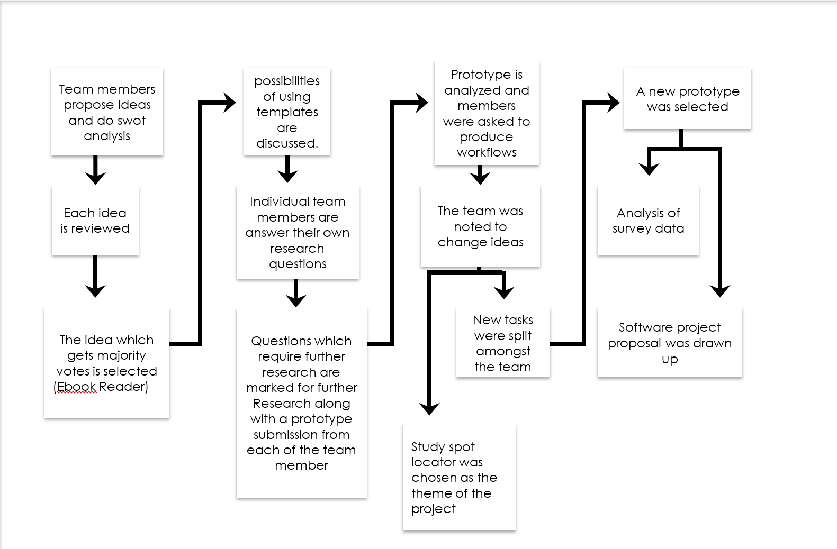

**Appendices**

## **Appendix 2**

Waze app Home Screen Waze app Search function

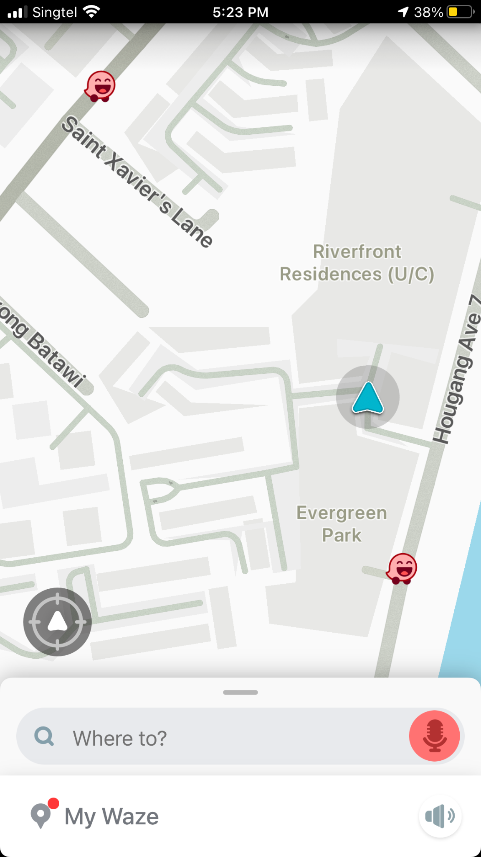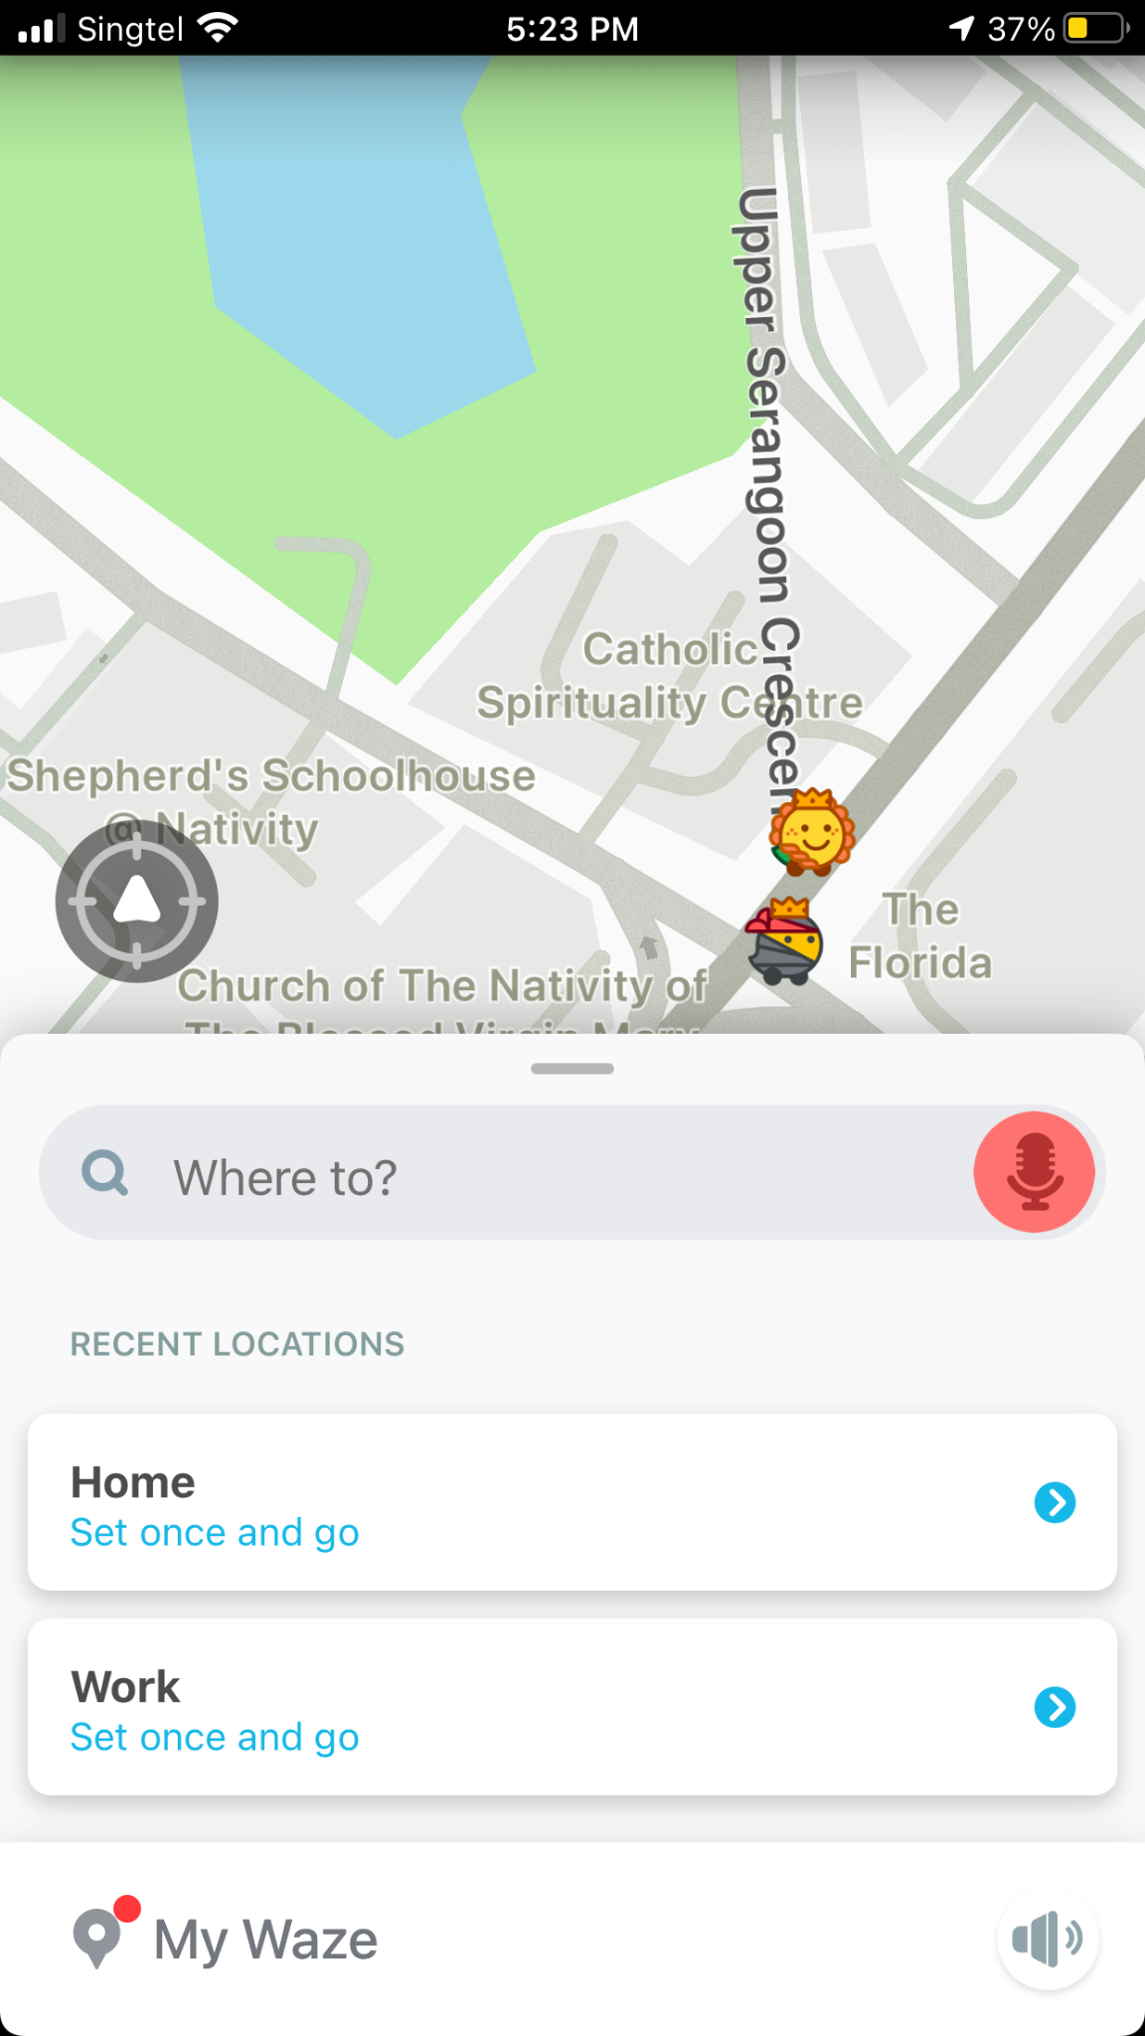

Source: Waze App

**Appendices**

**Appendix 2**

Waze app User Icons Waze app Menu Tab

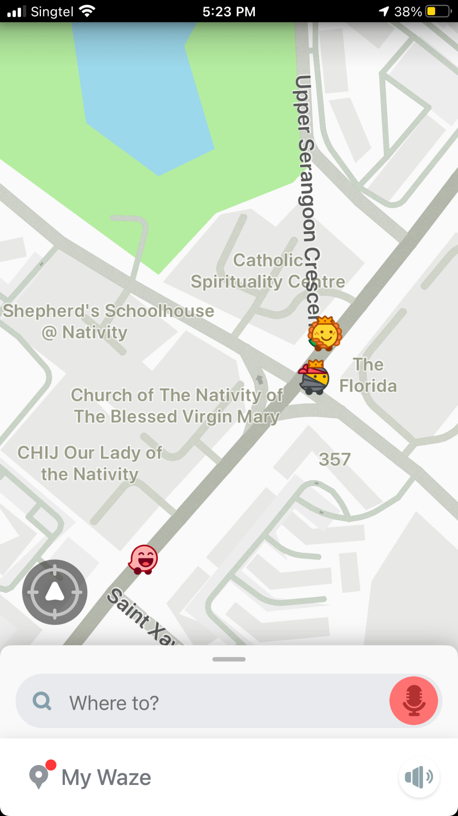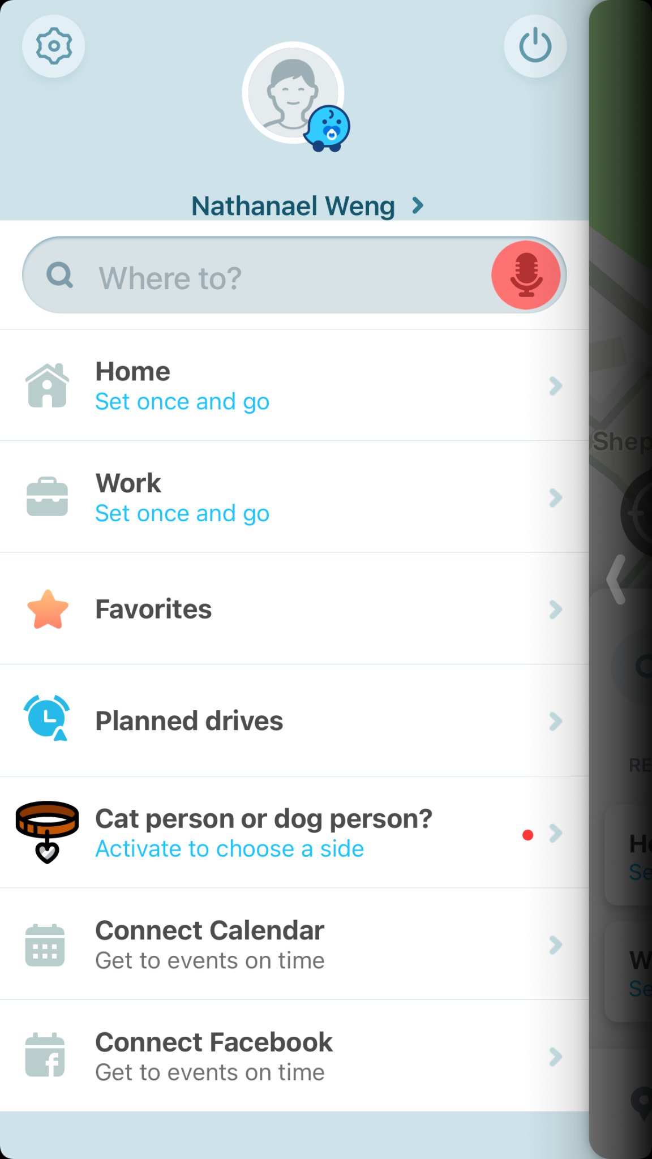

Source: Waze app

**Appendices**

## **Appendix 3**

Fern app home screen

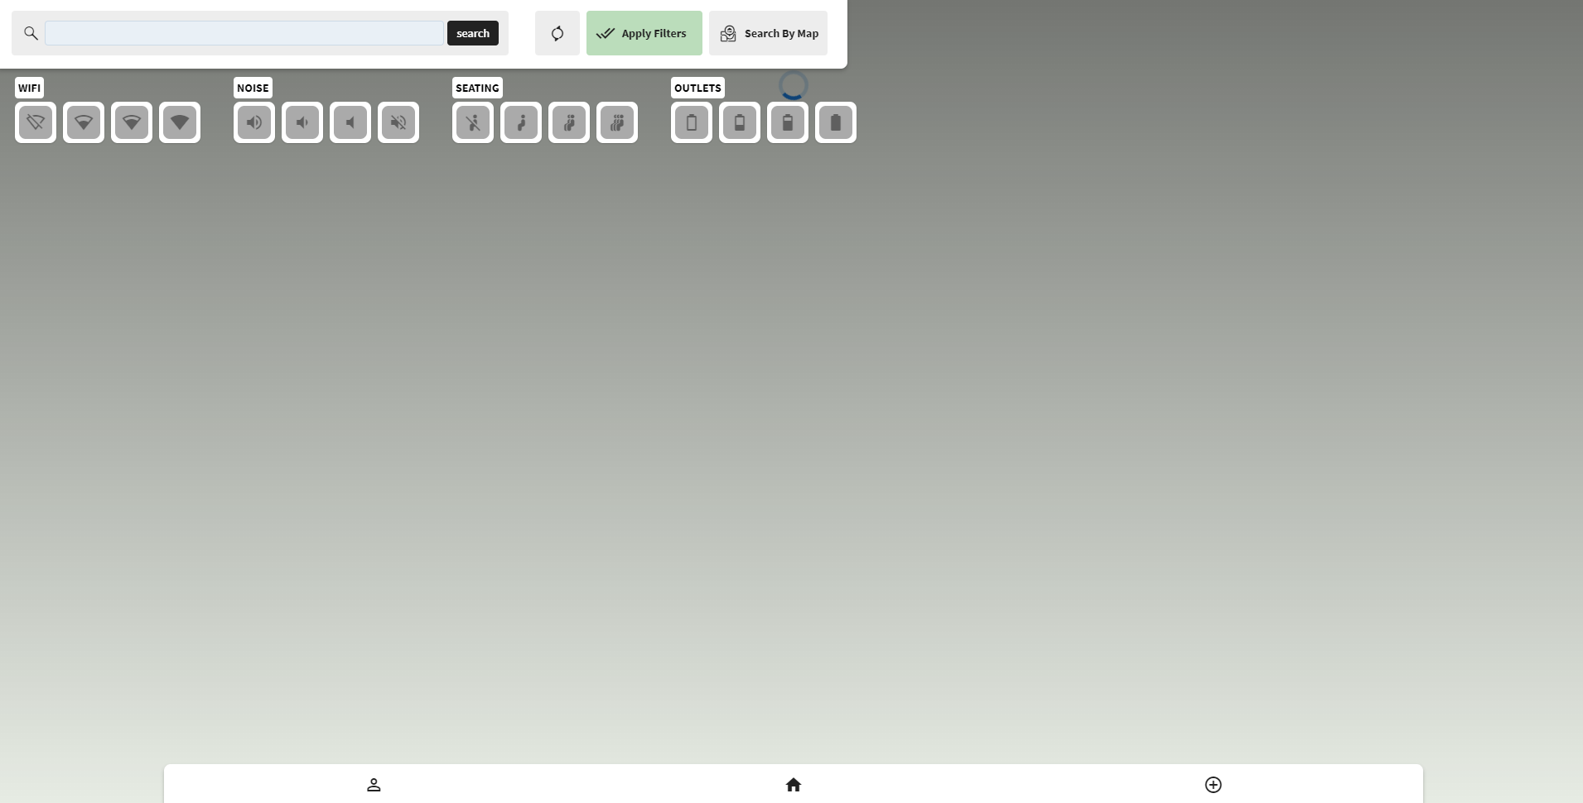

Source: <https://app.fernapp.co/SearchLocations/Home>**Appendices**

## **Appendix 4**

Reorganized survey data

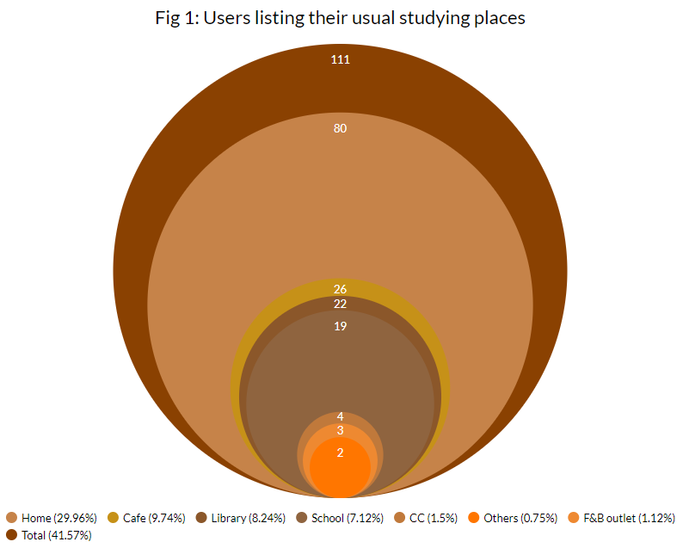

Source: https://docs.google.com/spreadsheets/d/1pwGTJcxzteMUlVlQUg716n-7Bd4Xh5lk3LemQADHRAg/edit?usp=sharing

**Appendices**

**Appendix 4**

Reorganized survey data

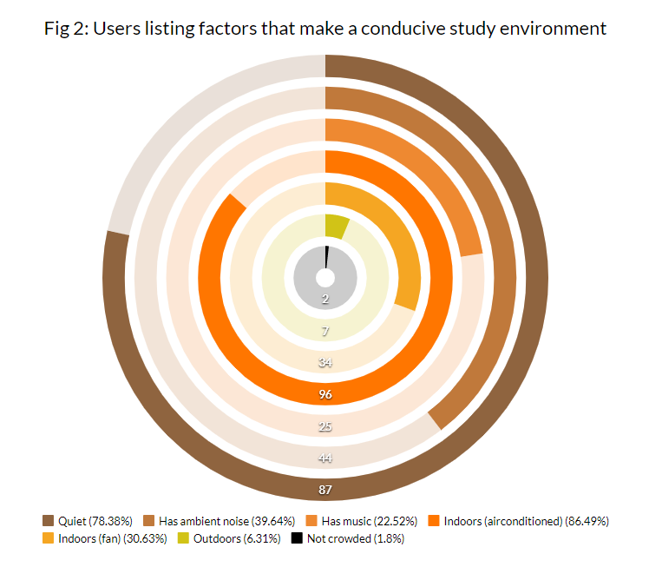

Source: https://docs.google.com/spreadsheets/d/1pwGTJcxzteMUlVlQUg716n-7Bd4Xh5lk3LemQADHRAg/edit?usp=sharing

**Appendices**

**Appendix 4**

Reorganized survey data

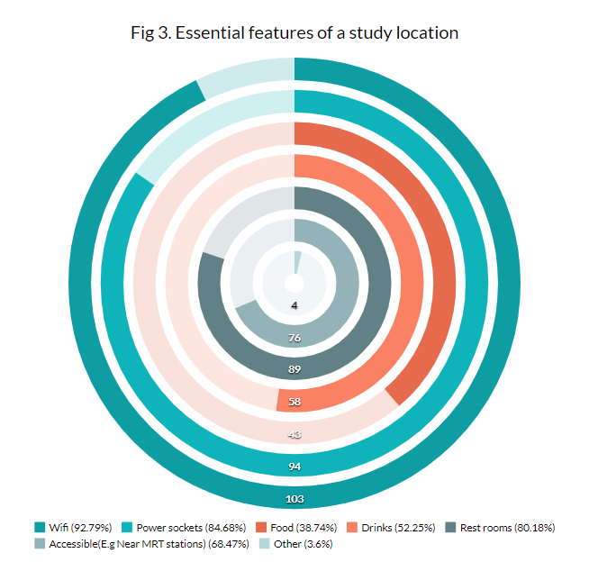

Source: https://docs.google.com/spreadsheets/d/1pwGTJcxzteMUlVlQUg716n-7Bd4Xh5lk3LemQADHRAg/edit?usp=sharing

**Appendices**

## **Appendix 5**

User persona: Cafe Cammy

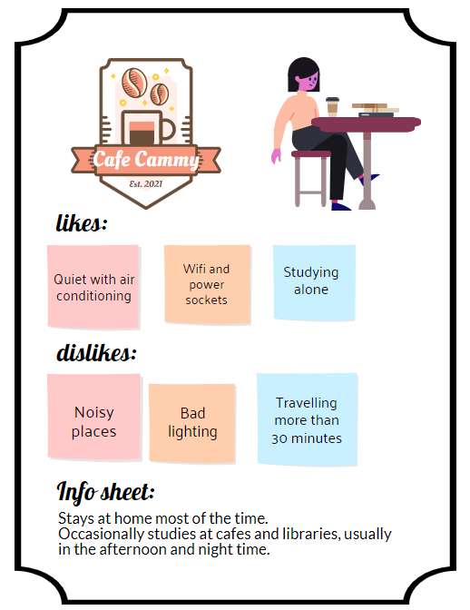

**Appendices**

## **Appendix 6**

Links to task flow diagram:

Login and register account: <https://miro.com/app/board/o9J_l9wibSE=/>

Forget password: <https://miro.com/app/board/o9J_l93ZA9E=/>   
Add new location: <https://miro.com/app/board/o9J_l9Etic4=/>

# **Individual Contributions**

# In some cases, completing tasks with other people can be a challenging task, but fortunately, I work very well with team members. Our project is to develop an application so that users can find a good learning space. We have weekly meetings to keep track of each team member's progress. My contribution helped our team project to be successful. First and foremost, I will attend every meeting on time. Whenever our team leader asks some questions, I will give good suggestions. Besides, I will complete the tasks assigned by our team leader, such as SWOT analysis in the project, and think about some survey questions, etc. Each team member has his own task; I am the part responsible for evaluation techniques. For evaluation techniques, I searched a lot of research to find better evaluation techniques that can be used in our projects. Besides, when teammates encounter some problems, I will give some important suggestions and help. When writing this report, I also helped my teammates proofread grammar, punctuation, and formatting.

# **References**

Coursera. 2021. *Test early, test often, iterate*. [online] Available at: <<https://www.coursera.org/learn/uol-cm2020-agile-software-projects/lecture/O3DCx/4-201-test-early-test-often-iterate>>

Sciencedirect.com. 2021. *Formative Testing - an overview | ScienceDirect Topics*. [online] Available at: <https://www.sciencedirect.com/topics/computer-science/formative-testing>

Tianlin Wang. 2021. *UX | Study Space Finder App — Tianlin Wang*. [online] Available at: <https://www.tianlinw.com/product-design-study-space-finder-app>

Studyspace.umn.edu. 2021. *Study Space | UMN Study Space Finder*. [online] Available at: <https://studyspace.umn.edu/>

Library.louisville.edu. 2021. *UofL Libraries: Study Space Finder: Home*. [online] Available at: <https://library.louisville.edu/ekstrom/study-space-finder>

Tutorialspoint.com. 2021. *SDLC - Iterative Model - Tutorialspoint*. [online] Available at: <<https://www.tutorialspoint.com/sdlc/sdlc_iterative_model.htm>>

Tutorialspoint.com. 2021. *SDLC - Agile Model - Tutorialspoint*. [online] Available at: <https://www.tutorialspoint.com/sdlc/sdlc_agile_model.htm>.

En.wikipedia.org. 2021. *Kotlin (programming language) - Wikipedia*. [online] Available at: <<https://en.wikipedia.org/wiki/Kotlin_(programming_language)>>

Guru99.com. 2021. *Kotlin vs Java: What's the Difference?*. [online] Available at: <<https://www.guru99.com/kotlin-vs-java-difference.html#:~:text=Kotlin%20combines%20features%20of%20both,and%20Java%20supports%20implicit%20conversions>.>

Google Developers. 2021. *Maps SDK for Android overview | Google Developers*. [online] Available at: <https://developers.google.com/maps/documentation/android-sdk/overview?section=start>